VE330 Lab 3
Pre-Lab Report
叶飞扬
5093709088

- (i) For Rat – Race 3dB couplers, assume they have four ports. Name the up-left port “Port 1”, and then name other ports from “Port 2” to “Port 4” clockwise. So the scattering parameters for the coupler is:

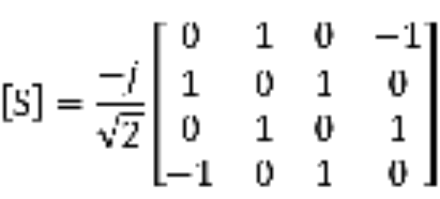

(ii) For Branch – Line couplers, also assume they have four ports and name them in the same way as in Rat – Race. So the scattering parameter for the couple is:

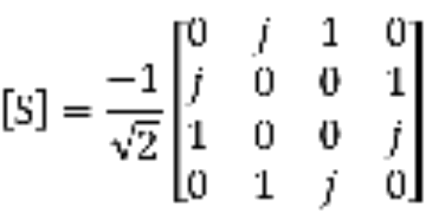

From these two parameters, the major difference is that for Rate – Race couplers, the isolated port is port 3 because 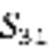 is 0. But for Branch – Line couplers, the isolated port is port 4 instead.

- (i) Draw the circuit for a Rat – Race coupler.

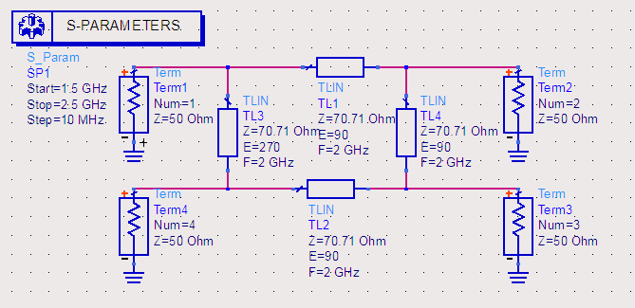

According to the S parameters above, it’s clear that port 3 is isolated and port 1 has no reflection since it’s a matched network. So the plot of 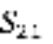and 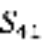 is shown below:

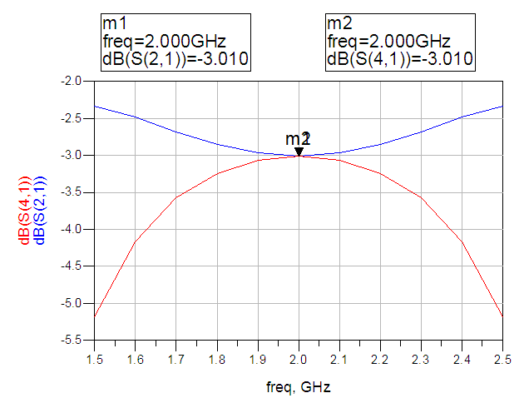

The transmission phase at coupled ports is shown in the following plot:

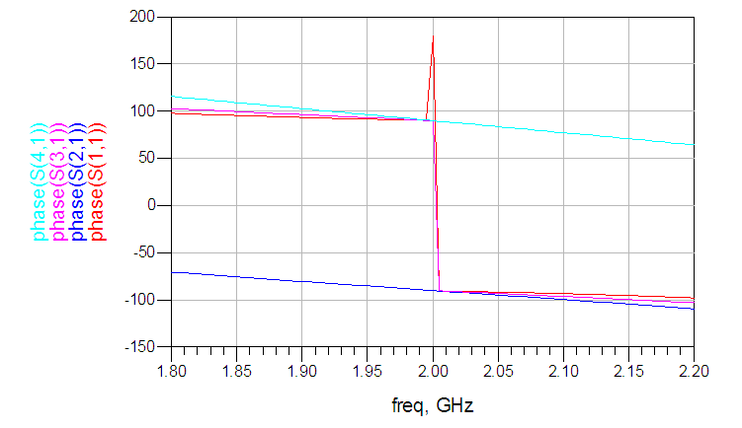
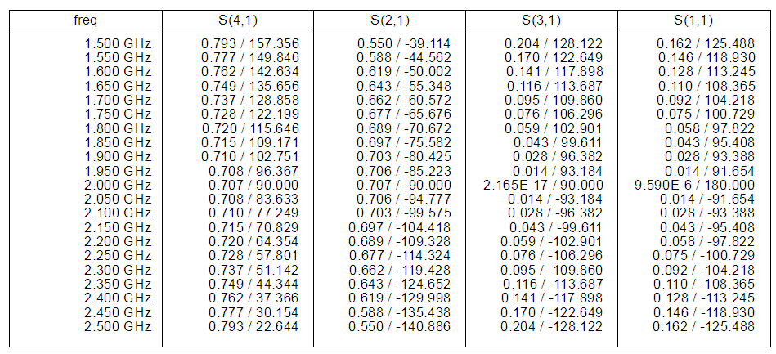
From the figure we can see that when the frequency is 2GHz, the phase of four ports is 180°, -90°, 90°and 90°.

(ii) For Branch – Line coupler, first draw its circuit.

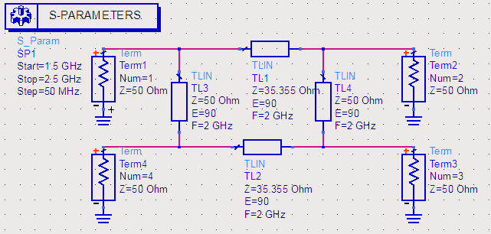

According to the S parameters above, it’s clear that port 4 is isolated and port 1 has no reflection since it’s a matched network. So the plot of and is shown below:

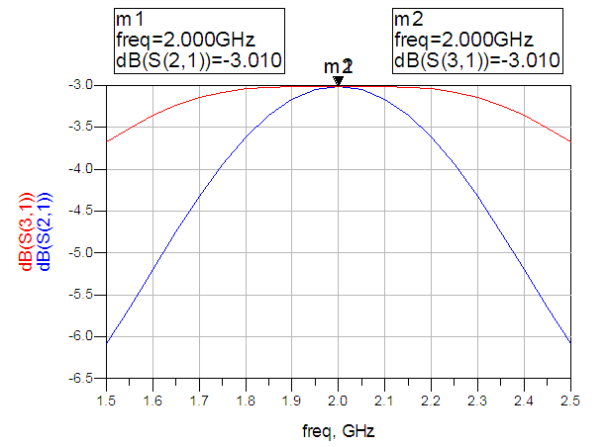

The transmission phase at coupled ports is shown in the following plot:

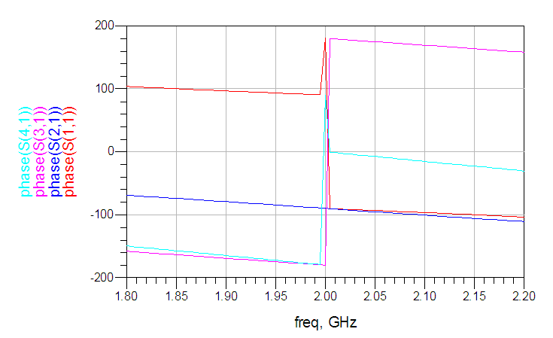

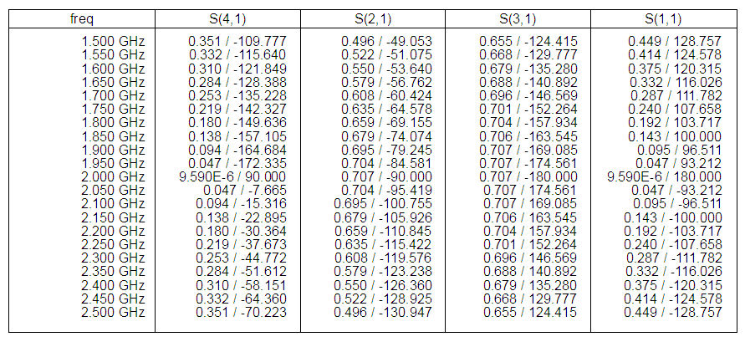
From the figure we can see that when the frequency is 2GHz, the phase of four ports is 180°, -90°, -180°and 90°.

(iii) First, compare the transmission phase with the S parameters shown above. These values are all expected and right.
Then, by comparing the transmission phase between coupled ports of these two kinds of couplers, it is clear that for Rat – Race couplers, which is also named as 180° coupler, the phase difference between two coupled ports, port 2 and port 4, is 180°. And for Branch – Line couplers, which is also named as 90° coupler, the phase difference between the coupled ports, port 2 and port 3, is 90°.

- With the parameters of microstrip line, the length and width of each transmission line is calculated first. By using the tool “LineCalc”, we get that for those lines with length λ/4, the actual length should be 1004.3 mil and the actual width should be 72.08 mil. And for the one with lengthλ*3/4, the actual length should be 3012.9 mil.
Next, the scheme is drawn in the following figure:

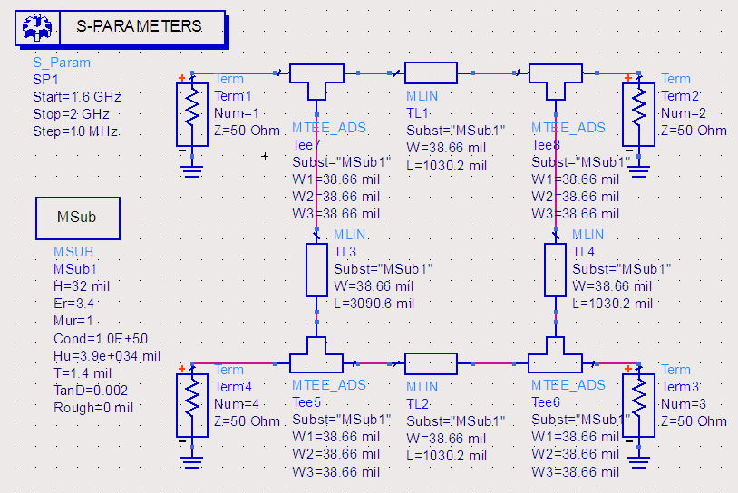
And all the S parameters are shown in the following two plots:

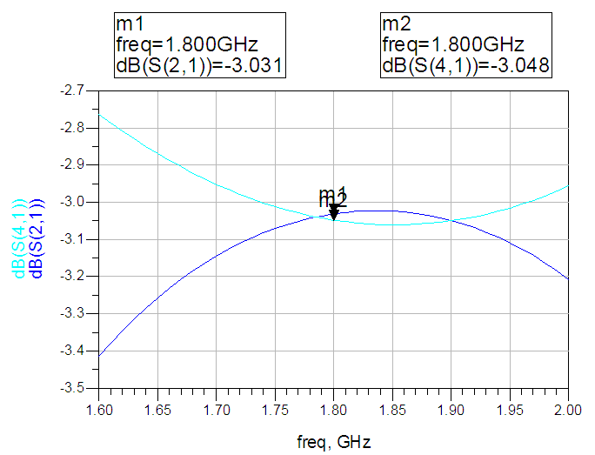

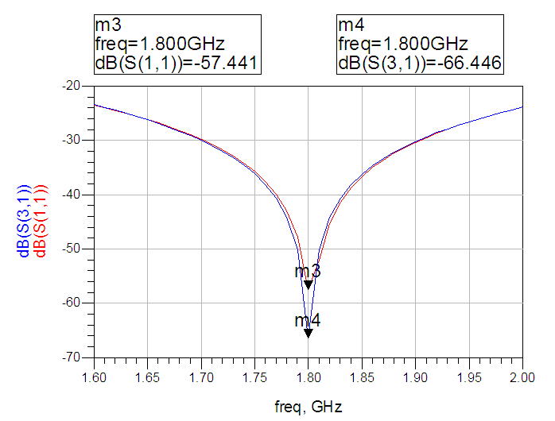

Finally, do the layout for the scheme.

